Python vs JAVA vs PHP vs PERL vs Ruby vs JavaScript vs C++ vs TCL

Python is a very versatile language people use it for almost everything. Python is ranking top language. According to PYPL that rank programming language by analyzing how often language tutorials are searched on Google.

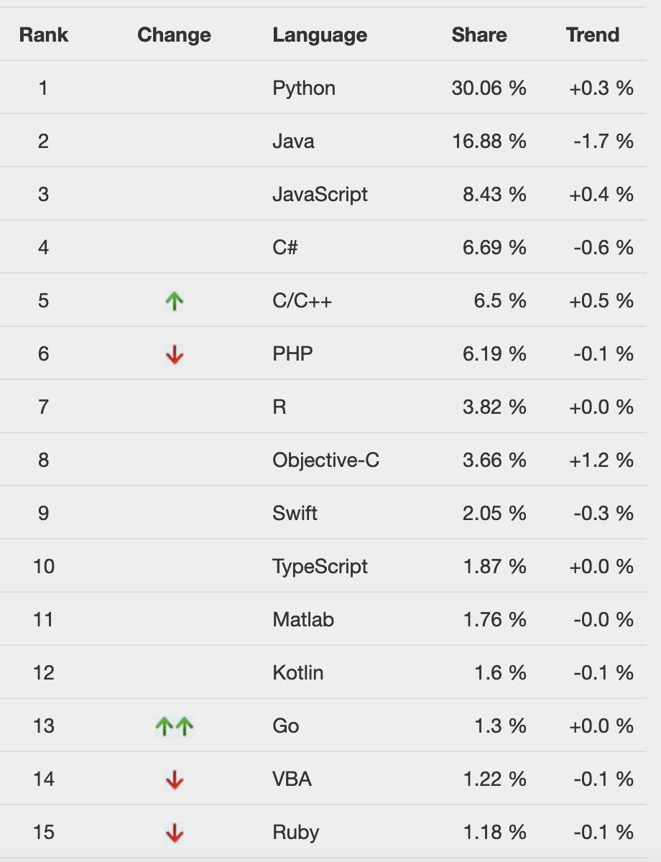

Let’s take a look at key features of some programming languages.Currently, following six languages are being used for developing both desktop and web applications.

* Ruby
* Java
* C++
* PHP
* TCL
* Perl
* JavaScript

That is why, it is important for programmers to compare Python with JAVA, RUBY, PHP, TCL and Perl to pick the right language for their projects

## Ruby

* compare to Ruby, Python has a rich set of data structures, internal functions, better namespace handling and use of modules and iterators
* Ruby does not support multiple inheritance while Python supports multiple inheritance
* Python uses while space for handling scopes but Ruby uses “end” or “}.
* RUBY is preferred for Web development and functional programming while Python for Academic and scientific programming.
* Ruby work on “Do more with less.” Philosophy while PYTHON “One right way to do things”

## JAVA

* Python is more human readable than JAVA
* Python has a high-level data types and its dynamic typing programs are shorter than Java programs

## C++

* Python code is quite shorter than most other programming languages like C or C++.
* Python is a dynamically typed language, while C++ is a statically typed language
* Python has a large support for built-in functions as compared to C++

## PHP

* Python is more readable while PHP has more syntax from C/C++ and Perl
* Python is easy to install as compared to PHP
* Python is slow as compared to PHP
* Debugging is easy in Python as compared to PHP
* Python supports major GUI frameworks

## TCL

* Tcl is a week on data structures standalone programming language
* TCL is slow as compared to Python

## PERL

* Perl is application oriented while Python is object oriented.
* Perl supports tasks like report generation, file scanning while Python focus on data structures and general programming language
* Python is more readable than Perl

## JavaScript

* Python is server side. JavaScript is client side.
* Python is extensively used in AI and machine learning while JavaScript lag in this property
* Python uses indentation and whitespace. JavaScript uses curly brackets to designate blocks of code.